LAB # 3
Introduction to Concurrency
OBJECTIVE
Understanding and implementing the concept of concurrency through different mechanisms of multithreading.
Lab Task:
1. Implement the following program on eclipse IDE and answer the following questions:
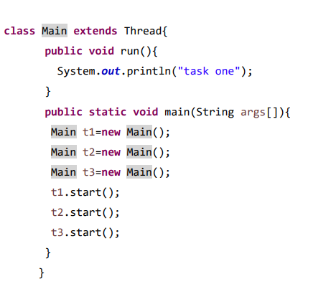

1. How many threads are running?
Ans: 4 threads are running in total.1 main thread (which runs the main() method) and 3 child threads (t1, t2, and t3) that execute the run() method concurrently.
2. How many tasks are running?
Ans:3 tasks are running. Each thread executes the run() method, which performs the task of printing "task one". So, there is one task per thread.

3. If more tasks are added, what will be the impact on number of threads?
Ans: If more tasks (threads) are created and started, the number of threads will increase.
Each new thread object created using new Main() and started with start() will run independently.
However, too many threads can reduce performance due to higher CPU load and context switching.

4. Explain the flow of program:
Ans ; The program starts with the main thread executing the main() method.
Inside main(), three thread objects (t1, t2, and t3) are created but not yet running.
When t1.start(), t2.start(), and t3.start() are called, three new threads begin execution concurrently.
Each thread calls the run() method and prints "task one" to the console.
The output order may vary because all threads run simultaneously.
Once all threads complete their execution, the program terminate.

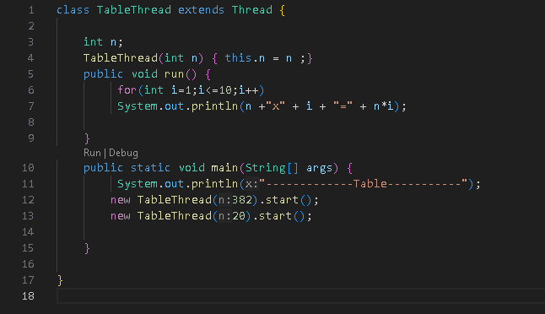
2. With the help of threading print two tables concurrently, print one table number of student roll number e.g. 2019-SE-092 and second number should be date of birth e.g. 05-April.

